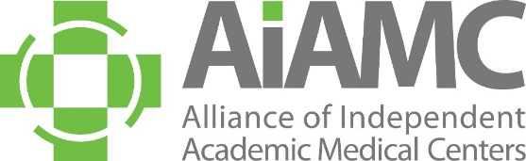

Group Discount Rates for Live Webinars

Contact Person:
Title:
Organization:
E-Mail:
Registration Fees:
5-9 registrants from the same institution (25% discount)

10 or more registrants from the same institution (50% discount)

Please check the webinar(s) for which you are registering. Note a separate form is needed for each webinar unless the attendees are the same for each one.

 | February 3 | 2021 in Review: Lessons Learned from the Disruptions of COVID-19, Hurricane Ida, and More
 | March 3 | JEDI Series: CLER Site Visits and DEI: Good Examples to Share
 | April 7 | Leadership Series: How to Run Successful Meetings
 | June 2 | Education Post-Covid: Virtual Learning, Workforce Needs, and Integration of Healthcare Ethics
 | July 7 | JEDI Series: AAMC Center for Health Justice
 | August 4 | Leadership Series: Recognize and Respond to Warning Signs in Students/Residents/Faculty
 | October 6 | Teaming Post-COVID: Building Resilient Healthcare Teams
 | November 3 | JEDI Series: Overcoming Racism and Injustice in Healthcare Education (AACOM)
 | December 1 | Leadership Series: The Games We Play – The Importance of Having a Challenge Mindset Versus a Threat Mindset

Registrant Information
 | NAME | EMAIL ADDRESS
1.
2.
3.
4.
5.
6.
7.
8.
9.
10.
11.
12.
13.
14.
15.
Please add additional lines if needed.

Payment:
□ American Express □ Visa □ MasterCard
Account #:
Amount: Exp. Date: CCID Code:
Cardholder’s Name:

Return to Laura Kasner via email - laura@aiamc.org
You may also call Laura at (cell 330-256-7943) with credit card information

