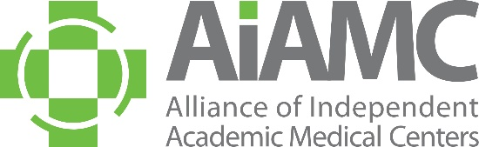

ALLIANCE OF INDEPENDENT
ACADEMIC MEDICAL CENTERS
2020 Annual Meeting
Call for Breakout Session Proposals

All AIAMC members are invited to submit a proposal for a breakout session at the 2020 AIAMC Annual Meeting, to be held March 26th – 28th at the Omni Barton Creek Resort and Spa in Austin, Texas. Breakout sessions must have a hands-on workshop format that provides practical tips on applying the principles presented in the plenary sessions and will be 75 minutes in length. Proposals are due no later than September 13, 2019 and all submitting presenters will be notified of the selection committee's decision by mid -October.
These breakouts will feature AIAMC members who have good stories to share. Session content should support the meeting theme of Demonstrating the Value Proposition of Education as follows:
• Quality and Safety • Service Vs. Cost • Leadership • Teaming • Value from the Perspective of Patients • Value from the Perspective of Learners • Value from the Perspective of Faculty• Value from the Perspective of the C-Suite
Breakout sessions should have a hands-on workshop approach and be highly interactive. Prior to submitting your proposal, please review the example provided of a prior breakout session proposal that was accepted by the planning committee. We hope this exemplar will be helpful to you as you develop your institution’s proposal(s).
A selection committee – made up of AIAMC members serving on the 2020 Annual Meeting Planning Committee – will determine which proposals are accepted. Submitters will be notified of the committee’s selections in mid-October. All accepted presenters are required to register for the conference. In accordance with AIAMC policy, all registration fees and travel expenses will be the responsibility of the presenter’s home institution. Submitting a proposal is a commitment that, if the proposal is accepted, all proposed presenters will attend the 2020 Annual Meeting and conduct the session at the time assigned.
We encourage you to submit a proposal and look forward to seeing you at the meeting!

